Image Processing

Histogram of Oriented Gradients Implementation

Assignment Report

Under the guidance of:

Prof. Dr.-Ing. Milan Gnjatovi´c

Presented by:
Rudradeep Palit
11038108

Purpose:
The main purpose of the project is to provide a tool for comparing images based on their texture and shape characteristics represented by the HOG descriptors. This allows for effective image analysis and similarity assessment, which can be useful in various applications such as object recognition and scene understanding.
Key Features and flowchart:
Loading Images: The program loads two grayscale images from specified file paths.
Grayscale Conversion: The loaded images are converted to grayscale using the luminosity method.
HOG Descriptor Calculation: The program computes the Histogram of Oriented Gradients (HOG) descriptor for each grayscale image. This involves dividing the image into cells, calculating histograms of gradients for each cell, normalizing these histograms, and flattening them into feature vectors.
Similarity Estimation: After obtaining the HOG descriptors for both images, the program calculates the cosine similarity between their feature vectors. This metric indicates how similar the images are based on their texture and shape characteristics.
Output: The program prints the cosine similarity value between the two input images, providing a quantitative measure of their similarity.

Variables that can be changed by the user:
- Number of Chaincode Directions: Users can adjust the variable numChaincodeDirections to change the level of detail in the HOG descriptor. Increasing this value may capture more detailed texture information, while decreasing it may result in a more generalized representation.
- Cell Size: Users can adjust the variable cellSize to change the size of the cells used for computing histograms of gradients. Larger cell sizes may capture more global information, while smaller cell sizes may capture finer details.
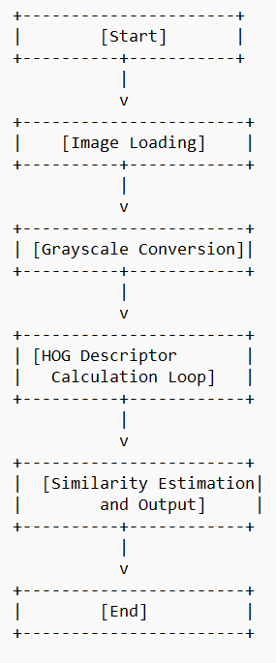

CODE COMPONENTS:
1. setup() Function:
Description: This function sets up the program, loads the images, converts them to black and white, calculates their HOG (shape) details, and finds out how similar they are.
2. toGrayscale() Function:
Description: Converts a color image into a black and white image.
3. calculateHOGDescriptor() Function:
Description: Figures out the shape details of an image using the Histogram of Oriented Gradients (HOG) technique.
4. calculateGradient() Function:
Description: Measures how fast the color changes at each point in the image. This helps in understanding the shape of objects in the image.
5. createHistogram() Function:
Description: Counts how many times certain color changes occur in different directions in a small part of the image.

6. normalizeBlock() Function:
Description: Makes sure the shape details are in a standard format so that they can be compared easily.
7. flattenHistograms() Function:
Description: Makes the shape details of the entire image into one big list.
8. cosineSimilarity() Function:
Description: Compares the shape details of two images to see how similar they are.
These functions work together to understand the shapes in images and compare them to find out how similar they are.Conclusion:

OUTPUT:
I used two different images:
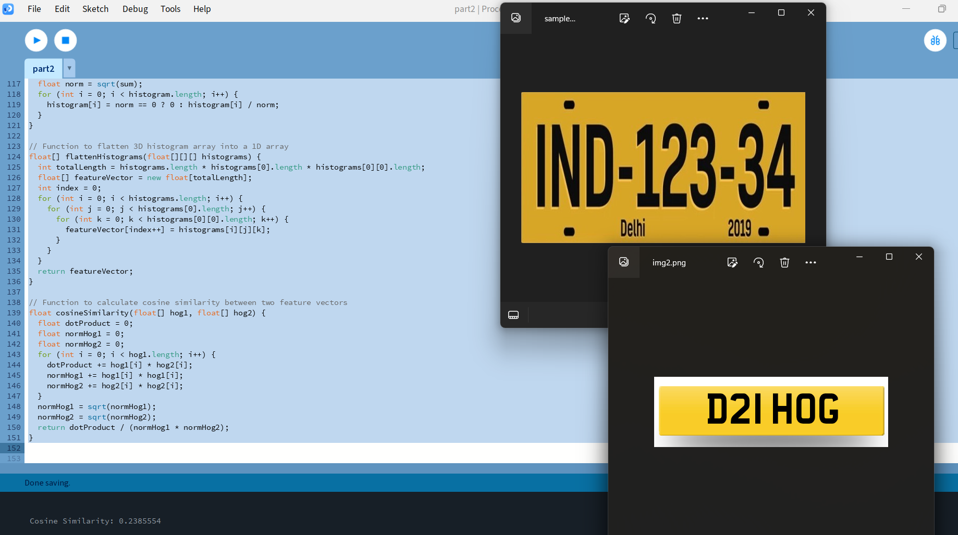

I used the same image for image1 and image2:
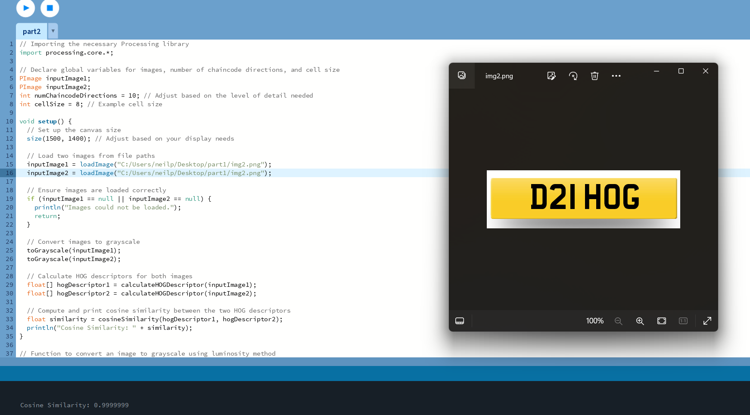

CONCLUSION:
The program computes Histogram of Oriented Gradients (HOG) descriptors for images, extracting texture and shape details. It calculates cosine similarity between descriptors to quantify image similarity. Adjustable parameters include "chaincode directions" and "grid dimensions", offering flexibility in capturing varying levels of detail for accurate image comparison.

Sources:
- https://medium.com/analytics-vidhya/a-gentle-introduction-into-the-histogram-of-oriented-gradients-fdee9ed8f2aa
- https://www.analyticsvidhya.com/blog/2019/09/feature-engineering-images-introduction-hog-feature-descriptor/
- https://www.analyticsvidhya.com/blog/2019/09/feature-engineering-images-introduction-hog-feature-descriptor/

